MODULE 4
— Digit extraction and number manipulation
QUES1. CODE:
#include <stdio.h>

int main() {
int T, N, first, last;

scanf("%d", &T);

for (int i = 0; i < T; i++) {
scanf("%d", &N);

last = N % 10;

while (N >= 10) {
N = N / 10;
}

first = N;

printf("%d\n", first + last);
}

return 0;
}
SCREENSHOT:
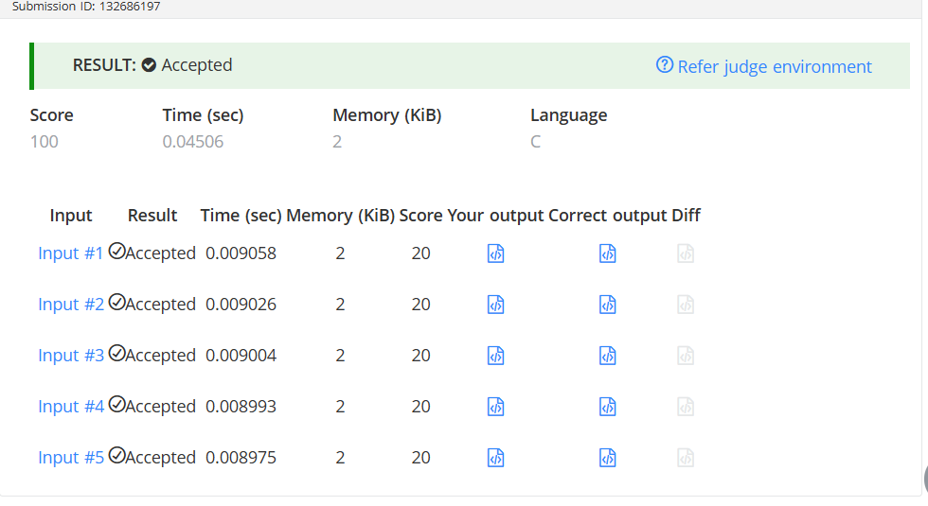
URL: https://www.hackerearth.com/problem/algorithm/digit-sum-4/
QUES 2. CODE:
#include <stdio.h>

int findDigits(int n) {
int temp = n;
int digit;
int count = 0;

while (temp > 0) {
digit = temp % 10;

if (digit != 0 && n % digit == 0) {
count++;
}

temp = temp / 10;
}

return count;
}

int main() {
int T, n;

scanf("%d", &T);

for (int i = 0; i < T; i++) {
scanf("%d", &n);
printf("%d\n", findDigits(n));
}

return 0;
}
SCREENSHOT:
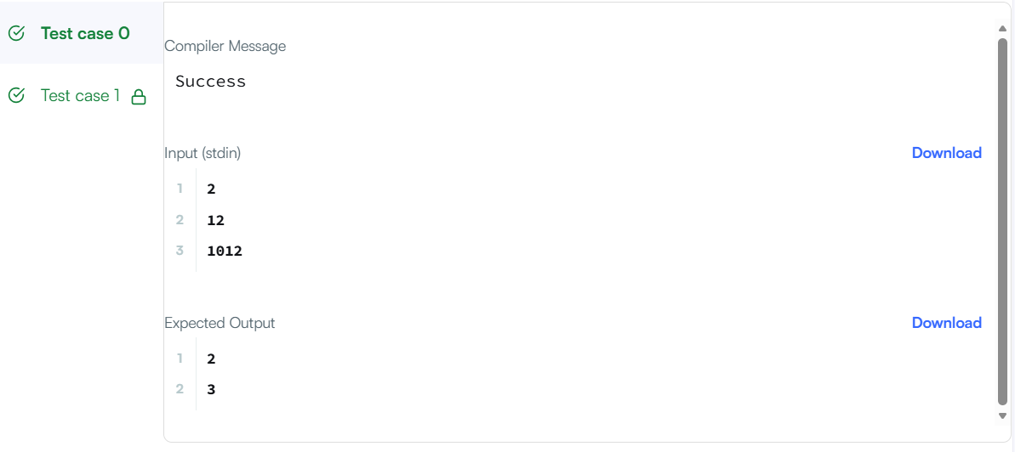
URL: https://www.hackerrank.com/challenges/find-digits/problem
QUES 3. CODE:
int subtractProductAndSum(int n) {
int product = 1;
int sum = 0;
int digit;

while (n > 0) {
digit = n % 10;

product = product * digit;
sum = sum + digit;

n = n / 10;
}

return product - sum;
}
SCREENSHOT:
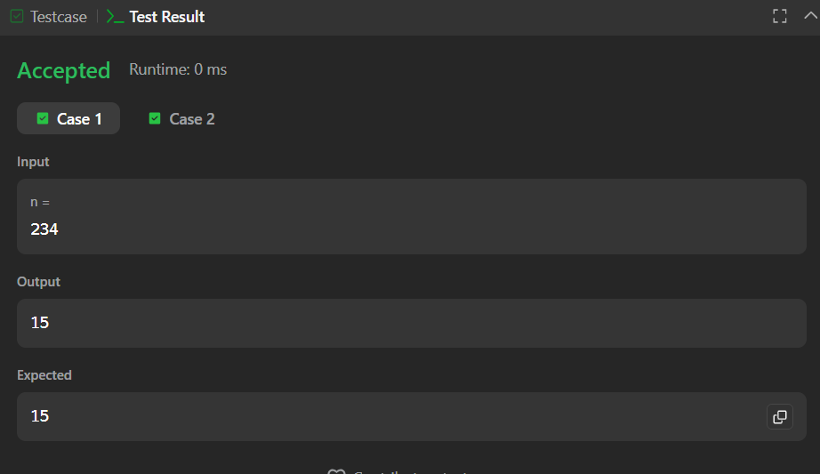
URL: https://leetcode.com/problems/subtract-the-product-and-sum-of-digits-of-an-integer/
QUES 4. CODE:
int countDigits(int num) {
int temp = num;
int digit;
int count = 0;

while (temp > 0) {
digit = temp % 10;

if (num % digit == 0) {
count++;
}

temp = temp / 10;
}

return count;
}
SCREENSHOT:
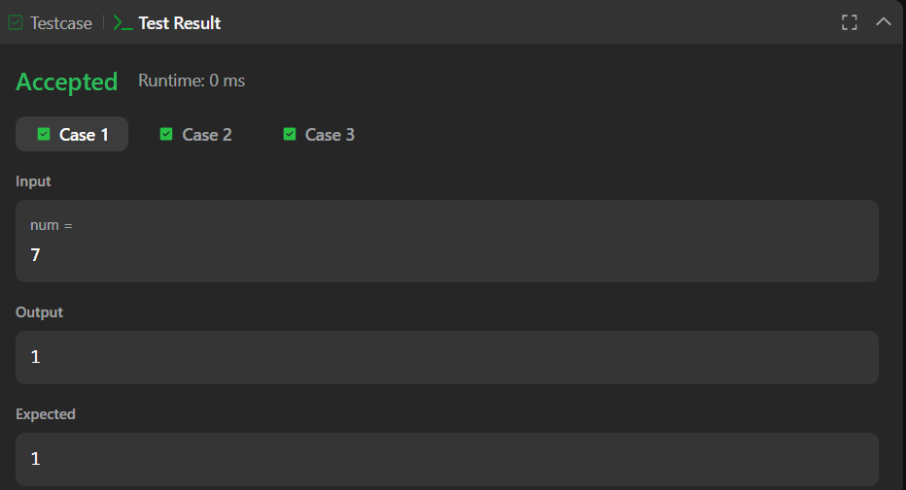
URL: https://leetcode.com/problems/count-the-digits-that-divide-a-number/
QUES 5. CODE:
bool isPalindrome(int x) {
int original = x;
int reverse = 0;
int digit;

if (x < 0) {
return false;
}

while (x > 0) {
digit = x % 10;
reverse = reverse * 10 + digit;
x = x / 10;
}

if (original == reverse) {
return true;
}
else {
return false;
}
}
SCREENSHOT:
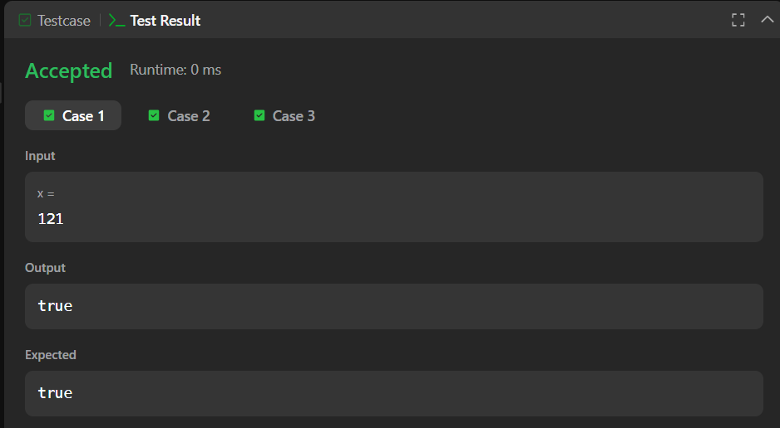
URL: https://leetcode.com/problems/palindrome-number/
QUES 6. CODE:
int reverse(int x) {
int rev = 0;
int digit;

while (x != 0) {
digit = x % 10;
x = x / 10;

if (rev > 214748364 || (rev == 214748364 && digit > 7)) {
return 0;
}

if (rev < -214748364 || (rev == -214748364 && digit < -8)) {
return 0;
}

rev = rev * 10 + digit;
}

return rev;
}
SCREENSHOT:
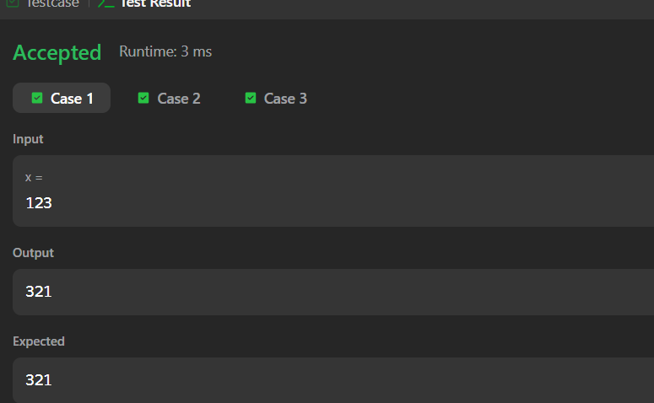
URL: https://leetcode.com/problems/reverse-integer/

